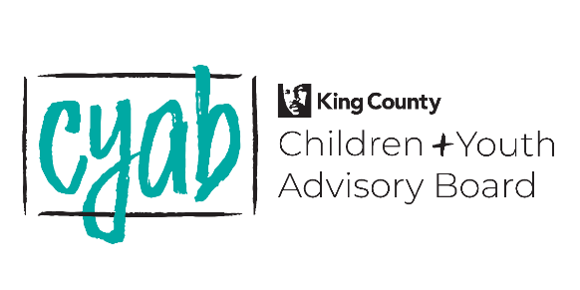
Department of Community & Human Services
401 Fifth Avenue
Seattle, WA 98104
October 10, 2023, BOARD MEETING MINUTES
Members Present: Angela Griffin, Nicole Herron, Debbie Peterson, Angela Griffin, Ariana Sherlock, Beth Larsen, Donald Felder, Jack Edgerton, Helena Stephens, Nicole Herron, Jessica Werner, Gloria Hoxsie, Meena Natarajan, James Lovell, Lidiya Gebre, Fernanda Martinez Novoa, Friday Hernandez Perez, Carol Goertzel, Annu Luthra, Yolanda Trout
Members Not Present: Erin Lee, Jackie Jainga-Hyllseth^{E}, Dwane Chappelle, Kendrick Glover, Suzette Espinoza-Cruz, Rita Alcantara, Kimmy Nguyen, Cindy Elizalde^{E}
Guests:
Staff Present: Eula Matsumoto, Kerry Wade and Zac Davis

6:00 PM, OCTOBER 10, 2023, VIA ZOOM

Meeting called to order: 6:05pm
No public comment was submitted.

- WELCOME & OVERVIEW OF AGENDA – Nicole & Angela
- CYAB Roll Call
- Recognition of guest(s) and viewing site host – 2 guests introduced themselves
- Approval of September Retreat Minutes (will approve in November)
- Overview of Meeting Agenda
September Retreat Recap and Reflection Time (optional small group discussion about the training on youth participation and combined power)

- OVERSIGHT & ADVISORY: Determining CYAB Additional Priorities – Angela Griffin
- Exercise to determine CYAB interests and focus points beyond Best Starts for Kids, the Puget Sound Taxpayer Accountability Account (PSTAA), and the King County Youth Action Plan

- BOARD BUSINESS: Subcommittee Report Outs & Discussion – Subcommittee Chairs
- Community Engagement – Cindy
  - Update on plans for the Best Starts for Kids Summit
  - Ariana sent out an email to Kerry to get a sign up sent out so folks can sign up for when they’re available
  - Scheduled a prep session for next Monday to prep people to present at the BSK Summit BSK Summit Prep Meeting 10/16 from 5-6pm
  - Summit is from 9am-5pm
  - https://www.signupgenius.com/go/10C0848AAA72FABFCC43-45065632-cyab/157097678#/
  - Summit is hybrid
  - If participating, to please register
  - click the link to register for the summit
  - https://whova.com/portal/registration/bkssu_202306/
- PSTAA Advisory Subcommittee – Jessica and James
- Oversees 3 pots of funding

- Young Leaders – Lidiya
-rebuild the subcommittee partnering with Roslyn
-there’s work that need to be done
- Care and Closure Advisory Committee – Jasmine
-things are moving forward
-subcommittees are meeting and leading to recommendations leading to a report come December
-who’s the audience for the recommendations? County Executive
- Youth Justice – Jasmine
-there’s a question about refocusing the subcommittee on something else
-if there’s not
-how many active folks and what type of participation is needed
-we don’t have the tools to do the fact finding that’s necessary to get into the work
-flounded a little bit. Everyone has a passion but no focus
-Rita reported that they lost members that were big to the committee
-lost a bit of steam/ not the best poised to do that work
-Trout mentioned that she went to a panel and mentioned 3 gentlemen that we should connect with and she still has passion for this too. Thinks we need a bit of help, need more involvement and input
-Felder expressed his passion for this work, someone needs to grab the reigns of the leadership role
-look at the mission again and to reorganize so members have some sort of direction
-CM Trout would like to step up as Co-Chair if Jasmine will have her
-Rita: The initial issue was the increasing numbers in detention and for longer times. The data was trending in the wrong direction. THe "why" is important- youth in detention are King County youth for which we are responsible for considering/supporting. And if we layer on our commitment for equity, incarcerated youth are/should be our priority and also because of pandemic and staffing, incarcerated youth perhaps have not been receiving services they need and should be getting
-Felder added that Rita’s suggestion in the chat is brilliant.
- State and future of the Youth Justice Subcommittee

- BOARD BUSINESS: CYAB Influence, Growth, and Relationships – Nicole Herron & Angela Griffin
- Invitation to county officials to speak to CYAB.
-great idea to get them to speak to the CYAB
-it would be great to have them in front of us so we can ask the questions we want
-we also need to have a strong relationship with these folks so they know who we are
-Breakout rooms for 10 minutes to come up with 3 questions
- What do you see as the biggest challenges for children, youth, and young adults in your district of the county.
-pattern of questions asking about what they think in regards to the youth
- Asking about commitment to youth; thoughts about the ending of the detention center in 2025- funding and alternative pathways for vulnerable youth.
Questions related to the role of culture, ethnicity;race abd gender in serving youth accessible and with equity and support
Question related to support for after-school activities for all ages- inclusive of youth transportation
Additionally- how are we sharing our story and asking how we could do that better?

- Board recruitment (deadline extended); Role of CYAB members.
Plans for December 2023 meeting
-rent a meeting room at round one
-provide a meal, there will be bowling/karaoke
-upcoming November meeting will finalize the details
-roslyn invited back potentially
-

Meeting adjourned at 7:48 pm

